Miguel Torres Perez

CST-150

Professor Smithers

Milestone 1

Initial model:

|  |  |  |
| --- | --- | --- |
| Item | Type | Description |
| Vanilla | Int | Icecream flavor |
| Chocolate | Int | Icecream flavor |
| Cherry | Int | Icecream flavor |
| Coffee | Int | Icecream flavor |
| Caramel | Int | Icecream flavor |
| Peanut butter | int | Icecream flavor |

Low Fidelity: 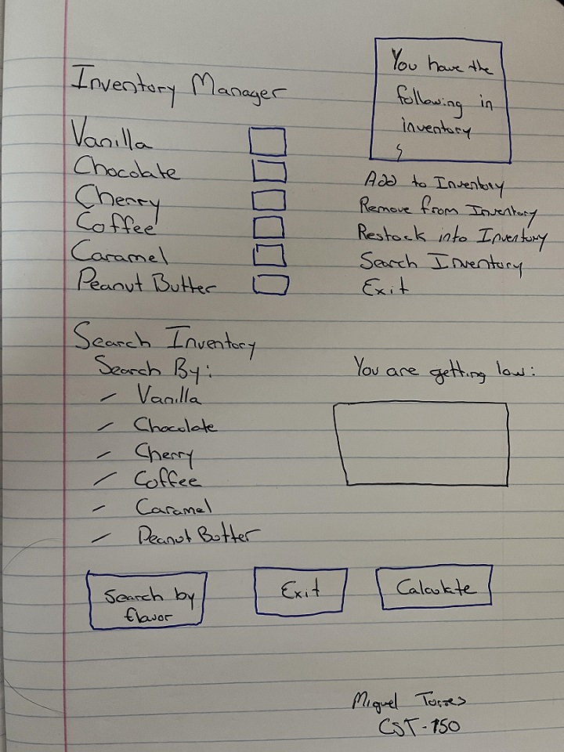

High Fidelity:

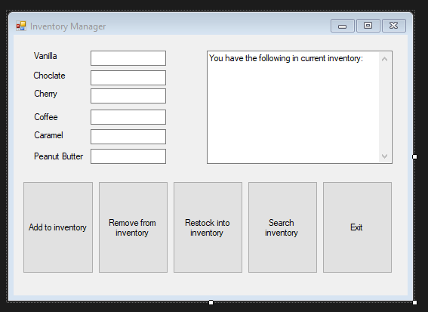

Within the Inventory Manager you can enter any amount into the Textbox and chose either to: Add, remove, or restock the item. The large Textbox to the right will adjust to show the current inventory after each change. The search inventory button will create a new pop up form ( see image below) where you are able to search the inventory from there.

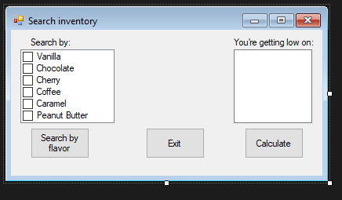

The Search Inventory form allows you to search by flavor, which will pop up a window to tell you what inventory you have for the selected flavor. The low on TextBox will list the flavors that have less than x amount in inventory.